Appendix 2

THE TOWN AND DISTRICT CENTRES, LONDON BOROUGH OF HARROW
PUBLIC SPACES PROTECTION ORDER 2023

This Order relates to the Town and District Centres in the London Borough of Harrow, highlighted on the attached plan

1. In this Order:

‘Anti-Social Behaviour’ refers to section 59 (2) (a)-(b) of the Anti-Social Behaviour, Crime and Policing Act 2014 and means: activities carried out, or which are likely to be carried out, in a public space which have a detrimental effect on the quality of life those in the locality. This also means behaviour likely to cause harassment, distress or alarm to one or more other person. This can include, but is not limited to, littering, verbal abuse, obstructing the highway, illegal drug use, urinating or, spitting

‘The designated area’ refers to any public space to which the public or a part of the public has access (S 74(1) of the Anti-Social Behaviour, Crime and Policing Act 2014). This can be with payment, or with express or implied permission. This can include businesses and communal areas of housing blocks but excludes residential premises. Prohibitions/requirements may vary for each designated area and will be highlighted accordingly on the attached plans.

‘Authorised officer’ refers to: police officer, police community support officer, or any other person designated to enforce the Order by London Borough of Harrow. You can require any authorised officers to produce authorisation before enforcing the Order.

‘Illegal or Unauthorised Street Trading’ includes persons selling from bags, trolleys, vehicles or any other mobile means.

2. The London Borough of Harrow, in accordance with Section 59 (7)(a) of the Anti-Social Behaviour, Crime and Policing 2014, identifies the following activities in the designated areas, highlighted in section 3 to 12
of this Order, as having had a detrimental impact on the quality of life of those in the locality, or it is likely that they will have such an effect

3. Town and District Centres as shown highlighted on the attached plan in Appendix 1 (‘the designated area’)
- Intimidating and/or aggressive begging
- Obstructing access to business premises during opening hours
- Leaving commercial waste in public spaces for an unreasonable length of time
- Use of amplification
- Financial Agreements on the Street
- Placing of tables, stands, or other furniture / fixings
- Distribution of leaflets
- Illegal or Unauthorised Street Trading
- Feeding of Birds and Vermin

4. Town and District Centres
As shown highlighted on the attached plan in Appendix 1 (‘the designated area’)

Requirements - In all public spaces within this designated area, you are required to:

4.1 Intimidating and/or aggressive begging

a. Disperse from the area for 24 hours if asked to do so by an authorised officer because you have been begging in a manner reasonably believed to be intimidating, aggressive or causing distress, or pose a risk to their safety or the safety of others.

4.2 Obstructing access to business premises during opening hours

a. Disperse from the area if asked to do so by an authorised officer because they reasonably believe that you have been obstructing the entrance of a commercial business without reasonable excuse during the course of its opening hours.

4.3 Leaving commercial waste in public spaces for an unreasonable length of time

a. Remove from the public space any commercial waste deposited or left there for the purposes of collection when asked by an authorised officer, because they reasonably believe that waste has been left in a public space for an unreasonable length of time or where applicable, outside of the specified timed collection slots.

4.4 Use of amplification

- Seek permission in advance from the Business Improvement District (BID) or London Borough of Harrow to use a microphone, loudspeaker, megaphone, loud hailer or any other similar equipment designed to, or which has the effect of amplifying the volume of speech or music.

NB This does not prevent free speech if carried out without the use of any equipment stated above.

4.5 Financial Agreements on the Street

a. If stopping people for the purpose of getting them to enter into financial agreements for charitable or other purposes, only operate from a set stand and approach people a maximum 2 metres from the stand.

4.6 Placing of tables, stands, or other furniture / fittings

a. Seek written permission in advance from the Business Improvement District (BID) or London Borough of Harrow to place any table, stand, furniture or other fittings in any part of the public areas within the Town Centre Restricted Areas.

4.7 Distribution of leaflets

- Seek permission in advance from the London Borough of Harrow Licensing Team to distribute any free leaflet, pamphlet or written word within the Town Centre Restricted Areas

NB This does not apply to charity, religious or political literature.

4.8 Illegal or Unauthorised Street Trading

- Seek permission in advance and obtain any necessary licence from the London Borough of Harrow Licensing team to sell any product or item in outdoor public spaces within the Town Centre Restricted Areas.

Prohibitions - In all public spaces within this designated area, you are prohibited from:

4.9 Feeding of Birds and Vermin

a. No person shall purposely deposit food or animal feed on the ground or on any structure or building in the public area to attract or feed wildlife, or vermin, within the Town Centre Restricted Areas.

5. Duration

The Order comes into effect on [date 2023] and will be in effect for a period of three years, [Date 2026].

If there is need to do so, the Council may shorten, extend or vary the order at any time in the three years. If the Council wants to extend or vary the Order, they must consult appropriate community representatives, the police and owners of the affected land on the variation.

6. Appeal

If any ‘interested person’ (a person living in, working in, or regularly visiting the affected area) wishes to appeal this Order, they must do so on one of two grounds (s 66 of the Anti-Social Behaviour, Crime and Policing Act 2014):

1) The Council did not have the legal power to make the Order.

2) The Council did not follow all the requirements listed in Chapter 2 of the Anti-Social Behaviour, Crime and Policing Act 2014.

The interested person(s) must appeal the Order with an application to the High Court within six weeks of the Order being made.

7. Information

Further information about the Town Centres PSPO and matters related within it, including licensing and seeking written permissions, can be found at www.harrow.gov.uk/licensing

8. Appendices

1 Designated area - Town and District Centres

Appendix 1 Designated area - Town and District Centres

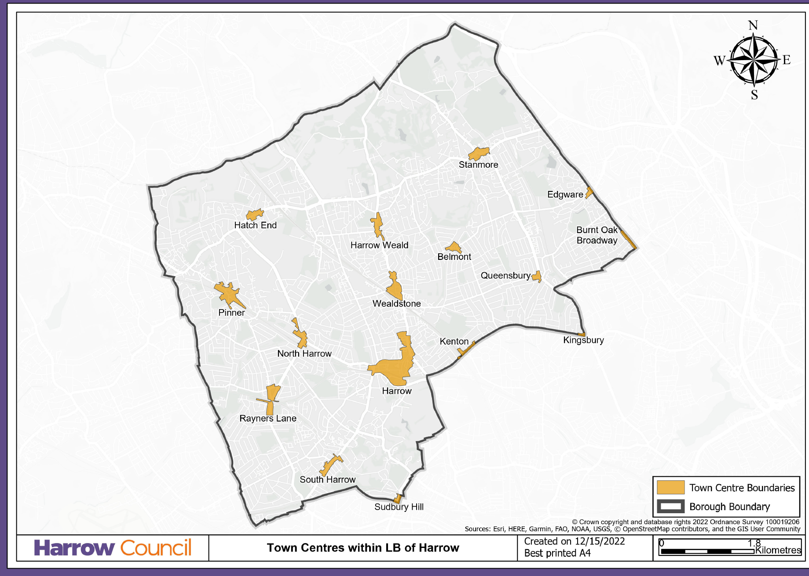

- Harrow, Pinner, Stanmore, Wealdstone, Hatch End, Harrow Weald, South Harrow, North Harrow, Rayners Lane, Belmont, Sudbury Hill, Kenton, Kingsbury, Edgware and Burnt Oak.

